The University of Georgia
Department of Management
MIST7600 – Organizational Memory Technologies
Final Examination
Fall 2001
Answer all questions

Ox
Answer the following queries based on the relational database described in the SQL Playbook.

Easy (3 points each)
- What are the salaries of the people in the Recreation department?
select empfname, empsalary from qemp where deptname = 'Recreation'
- List the employees sorted by department and within department by salary
select deptname, empfname, empsalary from qemp order by deptname, empsalary
- Report the colors of the different types of head coverings in the item table (they contain hat, helmet, or Stetson in their description)
select itemname, itemcolor from qitem where itemname like '%Hat%' or itemname like '%hat%' or itemname like '%Helmet%' or itemname like '%helmet%' or itemname like '%stetson%' or itemname like '%Stetson%'
- List the floors containing more than one department.
select deptfloor from qdept
group by deptfloor having count(*) > 1
- List the departments that have not sold compasses.
SELECT deptname
FROM qsale
WHERE deptname not in
(select deptname from qsale where itemname = 'Compass');

Hard (5 points each)

- Report the suppliers of deliveries that contain less than the average delivery quantity made by Nepalese Corp.
select distinct splname from qspl, qdel
where qspl.splno = qdel.splno
and delqty < (select avg(delqty) from qspl, qdel
where qspl.splno = qdel.splno and splname = 'Nepalese Corp.')

- Report those items delivered by suppliers who have made exactly one delivery to the Navigation department.
SELECT DISTINCT itemname
FROM qdel
WHERE splno in
(SELECT splno from qdel
where deptname = 'Navigation'
group by splno having count(*) = 1);

- Find the suppliers who deliver all the black items to the Clothes department.
SELECT splname
FROM qspl
WHERE not exists
(select * from qitem where itemcolor = 'Black'
and not exists
(select * from qdel
where qdel.itemname = qitem.itemname
and qspl.splno = qdel.splno
and deptname = 'Clothes'));

- You have been told that the profit on the sale of a Pith helmet is $5. Compute the total profit by department for all departments that sell pith helmets and order by decreasing profit.
SELECT deptname, sum(saleqty*5) AS profit
FROM qsale
WHERE itemname = 'Pith helmet'
GROUP BY deptname
ORDER BY sum(saleqty*5) DESC;

- Report the suppliers who have supplied the Recreation department and have also delivered Pith helmets (not necessarily in the same delivery).
SELECT DISTINCT splname
FROM qspl, qdel
WHERE qdel.splno = qspl.splno
and qdel.splno in
(select splno from qdel where deptname = 'Recreation')
and qdel.splno in
(select splno from qdel where itemname = 'Pith helmet');

Yak (24 points - 8 for each)
Answer each of the following:
- A car rental firm has commissioned you to design a multidimensional database for its marketing department. What identifier and variable dimensions would you select?
Identifiers: pickup location, return location, date, type of car, rental method
Variables: days rented, rental revenue, insurance revenue, miles
- List 3-4 major effects of the Web on data management? What types of products are available to address the issues raised by these effects?
- Managing the Web site: site maintenance software
- Connecting a database to the Web: PHP, ASP, JDBC
- XML: XML and style sheet editors
- Data volume increase: SANS
- Imagine you work as an analyst for a major mutual fund. What techniques would you use for the following questions (one word or phrase answers are appropriate):
- What were last year’s sales of utility funds by quarter and sales office?
OLAP
- How should the market for growth funds be segmented?
Clustering
- What is the potential revenue stream from a client who invests her retirement funds with the fund?
Prediction
- What is common about investors in tax-exempt funds?
Classifying
- What new funds do customers invest in the twelve months after investing in their first mutual fund?
Sequential patterns
- How do bond fund investors from other customers?
Classifying
- Assisting brokers to recommend funds to prospective investors.
Decision tree
- Identifying the characteristics of investors who invest in growth and index funds.
Association

Auroch (20 points)
The International Thesaurus of Quotations was impressed by your data model for Roget’s Thesaurus and has commissioned you to design the database to store the many quotations in its current edition (see the portion of the sample page that follows). Create the data model.
1002. UNEMPLOYMENT
- A man willing to work, and unable to find work, is perhaps the saddest sight that fortune’s inequality exhibits under this sun. THOMAS CARLYLE, Chartism (1839), 4.
- We believe that if men have the talent to invent new machines that put men out of work, they have the talent to put those men back to work. JOHN F. KENNEDY, address, Wheeling, W. Va, Sept. 27, 1962.
- No one gains from a fair employment practice bill if there is no employment to be had. JOHN F. KENNEDY, State of the Union Message, Jan. 14, 1963.

UNFAIRNESS
See 475. Injustice
1003. UNFULLFILLMENT
See also 364. Frustration; 711. Potential
- Meetings that do not come off keep a character of their own. They stay as they were projected. ELIZABETH BOWEN, The House in Paris (1935), 2.1.
- What we have never had, remains; It is the things we have that go. SARA TEAS-DALE, “Wisdom,” Dark of the Moon (1926).
1004.UNHAPPINESS
See also 249. Discontent; 407. Happiness; 911. Sorrow; 913. Sour Grapes; 939. Suffering; 1045. Weeping
- A man should always consider how much he has more than he wants, and how much more unhappy he might be than he really is. JOSEPH ADDISON, The Spectator 1711, 564.
- Nothing is miserable unless you think it so. BOETHIUS, The Consolations of Philosophy (A.D. 524), 2.
- Melancholy cannot be clearly proved to others, so it is better to be silent about it. JAMES BOSWELL, London Journal, May 17, 1763.

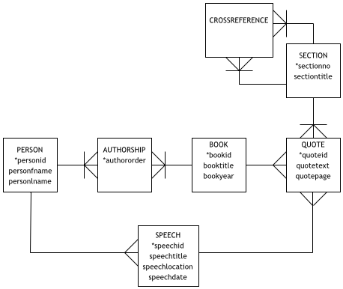
Bison ( 16 points)
Draw a hierarchical data model for the yellow pages (see the portion of the sample page that follows), write the DTD for this model, and the XML code to store the data for two entries.
Insurance
Insurance-Livestock

See Insurance-Farm

Insurance-Long Term Care

Costa Joe & Associates
180 Oakbend Ct Athens 706 546-6088

Farm Bureau Insurance of Oconee Co
1310 Greensboro Highway, Athens 706 679-0761

Mutual of Omaha Insurance Company
985 Gaines School Rd Athens 706 369-9005

Old Southern Insurers Inc
5230 Atlanta Hwy Bogart 770 725-6633

Primeria Financial Services/Bob Long & Associates
1165-B Cedar Shoals Dr 706 548-7560

Insurance-Medicare
Supplements

Mutual of Omaha Insurance Company
985 Gaines School Rd Athens 706 369-9005

Old Southern Insurers Inc
5230 Atlanta Hwy Bogart 770 725-6633

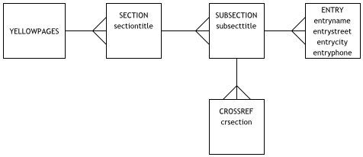

<!--DTD for yellowpages -->
<!ELEMENT yellowpages (section+)>
<!ELEMENT section (sectiontitle, subsection+)>
<!ELEMENT subsection (subsecttitle, crossref*, entry*)>
<!ELEMENT subsecttitle (#PCDATA)>
<!ELEMENT crossref (#PCDATA)>
<!ELEMENT entry (entryname, entrystreet, entrycity, entryphone)>
<!ELEMENT entryname (#PCDATA)>
<!ELEMENT entrystreet (#PCDATA)>
<!ELEMENT entrycity (#PCDATA)>
<!ELEMENT entryphone (#PCDATA)>

<?xml version = "1.0"?>
<!DOCTYPE phonebook SYSTEM "yellowpages.dtd">
<yellowpages>
<section>
<sectiontitle>
Insurance
</sectiontitle>
<subsection>
<subsecttitle>
Insurance-Livestock
</subsecttitle>
<crossref>
Insurance-Farm
</crossref>
</subsection>
<subsection>
<subsecttitle>
Insurance-Long Term Care
</subsecttitle>
<entry>
<entryname>
Costa Joe and Associates
</entryname>
<entrystreet>
180 Oak Bend Ct
</entrystreet>
<entrycity>
Athens
</entrycity>
<entryphone>
706 546-6088
</entryphone>
</entry>
<entry>
<entryname>
Farm Bureau Insurance of Oconee Co
</entryname>
<entrystreet>
1310 Greensborough Hwy
</entrystreet>
<entrycity>
Athens
</entrycity>
<entryphone>
706 769-0761
</entryphone>
</entry>
</subsection>
</section>
</yellowpages>

